5.114: The tension F in the string must be the same as the weight of the hanging block, and must also provide the resultant force necessary to keep the block on the table in uniform circular motion; 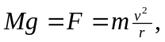 so 